
News And Entertainment
Final Year Project




Project Supervisor
Ms Kainat
Head of Department of Information Technology (IT)
The Islamia University of Bahawalpur

Project Team
Ahsan Sajjad
F22BINFT1M01172
Session 2022-2026

Department of Information Technology (IT)
The Islamia University of Bahawalpur

News And Entertainment

By
Ahsan Sajjad
Session 2022-2026
Roll no: F22BINFT1M01172
Project Submitted to
Department of Information Technology
The Islamia University of Bahawalpur
In Partial fulfillment of the requirements for the degree of

BACHELOR OF SCIENCE
IN
INFORMATION TECHNOLOGY (Honors)


………………………………
Project Supervisor

Abstract
A News and Entertainment Website is a dynamic web-based platform designed to provide users with the latest news, trending stories, entertainment updates, celebrity information, movies, music, sports, and other digital media content in an organized and user-friendly manner. With the rapid growth of online media consumption, users prefer accessing real-time news and entertainment content through responsive and interactive websites.
The main objective of this project is to develop a modern and efficient web application that allows users to easily browse, read, and explore various categories of news and entertainment content. The website provides an attractive interface where users can view articles, breaking news, featured stories, and multimedia content such as images and videos.
This project proposes a PHP-based News and Entertainment Website that manages and displays content dynamically using a database-driven system. The platform enables administrators to add, update, delete, and manage news articles and entertainment posts through an admin panel. Users can access different categories and stay updated with the latest information in real time.
The technologies used for the development of this project include PHP for backend development, MySQL for database management, HTML, CSS, and JavaScript for frontend design and interactivity. The project is developed using Visual Studio Code and runs on a local server environment such as XAMPP.
The system is designed to provide fast performance, easy navigation, and a responsive layout for better user experience across different devices. This project aims to create an informative and engaging online platform that delivers news and entertainment content efficiently and effectively.

Keywords:
News and Entertainment Website; PHP; MySQL; Web Application; Online News Portal; Entertainment System; Content Management; Dynamic Website; HTML; CSS; JavaScript

Acknowledgement
I would like to express my sincere gratitude to my supervisor, Ma,am Kainat, for her constant support, valuable guidance, and continuous encouragement throughout the development of this project. Her insightful suggestions, patience, and expertise played a vital role in the successful completion of my News and Entertainment Website project. Without her supervision and assistance, the completion of this project would not have been possible.
I would also like to thank all the teachers of the Department of Information Technology for their academic support, knowledge sharing, and guidance during my studies. Their teachings helped me build a strong foundation in web development, programming, database management, and system design.
Finally, I am deeply grateful to my family and friends for their unwavering support, motivation, and encouragement throughout my academic journey. Their continuous support helped me stay focused and successfully complete this project.

CERTIFICATE OF APPROVAL
Hereby we certify that the above mentioned Final Year Project " News and entertainment” was done by Muhammad Ahsan Sajjad having Roll No. F22BINFTIM01172 under our supervision and guidance. We have gone through the above mentioned project and found it satisfactory enough for submission for the partial requirement of Bachelors of Science in Information Technology.
Supervisor
Name : Kainat
Designation : Lecturer


Signature:
Date: 3/06/2026

Table of Contents
Chapter 1 4
1.1 Introduction 4
1.2 Background 4
1.3 Research problem 4
1.4 General Objectives 5
1.5 Specific objectives 5
1.6 Justification 5
1.7 Scope of the project 6
Chapter 2 7
Requirements Analysis 7
2.1 Introduction 7
2.2 Current situation 7
2.3 Challenges experienced 8
Chapter 3:System Development methadology 9
3.1: System methodology 10
3.2Evolutionary prototyping model 10
3.2.1Requirements analysis and specification 10
3.2.2Prototype Design 10
3.2.3Customer valuation 11
3.2.4Prototype Building 12
3.2.5Prototype Testing 12
3.2.6justification of methodology 12
3.2.7Functional requirements 12
3.3Authentication 12
3.3.1Administrative 12
3.3.2 Non-Functional Requirements 13
3.3.2.1 Usability Requirement 13
3.3.2.2 Reliability Requirement 13
3.3.2.3 Data Integrity Requirement 13
3.3.2.4 Security Requirement 13
3.5 Proposed Module and Architecture 13
3.5.1 User Module 13
3.5.2 Administrative Module 14
3.5.3 Security Module 14
3.6 System Development Tools and Techniques 14
3.6.1 HTML 14
3.6.2 Python (Django) 14
3.6.3 JavaScript 14
3.6.4 MySQL / SQLite 14
3.6.5 IDE 14
3.6.6 Case Studies 14
Chapter 4: System Design and Analysis 15
4.1 Functional Requirements 15
4.2 Non-Functional Requirements 15
4.3 Methodology and Setup of Experiment 16
4.4 House Rent Management System 16
4.5 Use Case Diagram 18
4.7 ER Diagram 19
E.R. diagram 19
4.8Flow Chart 20
4.9 Future Directions 22
4.10 Conclusions 22
4.12 Testable Requirements 22
4.13 Test results 23
-4.14 Interface 29
Chapter 5: Conclusion and Recommendations 30
5.1 Summary of the Objectives 30
5.2 Conclusions 30
5.3 Recommendations 31
References 32
Project-Specific References (Adjusted to Cyberbullying Detection System) 32

1.1 Introduction
The News and Entertainment Website is a web-based platform developed to provide users with easy access to the latest news, entertainment updates, celebrity information, sports, movies, music, and trending topics. In today’s digital era, online media platforms have become one of the fastest and most popular sources of information and entertainment. This project is designed to deliver dynamic and real-time content through a user-friendly interface using PHP and MySQL technologies.

1.2 Background
With the rapid growth of internet usage, people prefer online platforms over traditional newspapers and television for news and entertainment. Many websites provide digital content, but users often face issues such as slow performance, poor design, and outdated information. Therefore, there is a need for a responsive and efficient website that can manage and display news and entertainment content effectively. This project aims to fulfill that need by creating a modern web application with better accessibility and user experience.

1.3 Research Problem
Traditional methods of sharing news and entertainment content are less efficient compared to modern web-based systems. Many existing websites lack proper content management, fast updates, and organized categories for users. Additionally, some platforms are not mobile-friendly and do not provide a smooth browsing experience. The main problem addressed in this project is the development of a dynamic and responsive system that can efficiently manage and display news and entertainment content for users in a simple and attractive way.

1.4 General Objectives
The main objective of this project is to develop a dynamic News and Entertainment Website using PHP and MySQL that provides users with updated information and entertainment content through an interactive and user-friendly platform.

1.5 Specific Objectives
- To design and develop a responsive website for news and entertainment content.
- To create an admin panel for managing articles, categories, and posts.
- To store and retrieve data efficiently using a MySQL database.
- To provide users with easy navigation and access to different categories.
- To improve user engagement through an attractive frontend interface.

1.6 Justification
This project is important because it provides a centralized online platform where users can access the latest news and entertainment updates anytime and anywhere. It helps improve digital communication and information sharing while reducing dependence on traditional media sources. The system also allows administrators to manage content easily and efficiently, making it suitable for modern online publishing needs.

1.7 Scope of the Project
The scope of this project includes the development of a web-based News and Entertainment Website with features such as news posting, category management, article display, and admin control panel. The system is limited to online content management and user viewing functionalities. It is developed using PHP, MySQL, HTML, CSS, and JavaScript and is intended to run on a local server environment such as XAMPP.
窗体顶端

窗体底端

C

Chapter 2

2.1 Introduction
Requirements analysis is an important phase in system development that helps identify the needs and functionalities of the proposed system. This chapter explains the requirements of the News and Entertainment Website, including the current situation, challenges faced in existing systems, and the technologies required for the development of the project. The purpose of this analysis is to ensure that the system meets user requirements efficiently and provides a better online experience.

2.2 Current Situation
Currently, many people rely on online platforms and social media applications to access news and entertainment content. Existing websites provide various types of information such as breaking news, sports updates, celebrity news, movies, and music. However, some websites are difficult to manage, contain outdated content, and lack proper organization and responsive design. In some cases, users experience slow loading speed and poor navigation, which affects the overall user experience.

2.3 Challenges Experienced

1. Content Management Problems
Many existing websites face difficulties in managing large amounts of news and entertainment content. Updating articles, categories, and multimedia content manually can be time-consuming and inefficient for administrators.

2. Poor User Experience
Some websites have complex layouts, slow performance, and non-responsive designs that make it difficult for users to browse content smoothly on mobile devices and computers.

3. Lack of Security

Existing systems may not provide proper security mechanisms to protect user data and admin accounts. Weak authentication systems can lead to unauthorized access and data manipulation.

4. Limited Search and Navigation
Users sometimes struggle to find relevant news or entertainment content because of poor search functionality and unorganized categories.

5. Maintenance and Performance Issues
Traditional websites may become slow when handling large amounts of data and traffic. Maintaining and updating such systems can also become difficult without a proper content management structure.

Chapter 3:System Development methadology

System Design and Methodology

3.1 System Methodology
System methodology refers to the process and techniques used to develop the News and Entertainment Website. For this project, the Evolutionary Prototyping Model is used because it allows continuous improvement of the system based on user feedback and requirements. This methodology helps in developing a flexible and user-friendly system step by step.

3.2 Evolutionary Prototyping Model
The Evolutionary Prototyping Model is a software development approach where the system is developed gradually through different versions or prototypes. Each prototype is improved based on testing and user feedback until the final system is completed. This model is suitable for web applications because it helps identify problems early and improves system quality.

3.2.1 Requirements Analysis and Specification
In this phase, the system requirements are identified and analyzed. The functional and non-functional requirements of the News and Entertainment Website are gathered to understand user needs. Features such as article management, category management, user access, and admin control are defined in this stage.

3.2.2 Prototype Design
During the prototype design phase, the layout and structure of the website are created. User interfaces such as the homepage, news categories, entertainment pages, and admin dashboard are designed using HTML, CSS, and JavaScript to provide a simple and attractive user experience.

3.2.3 Customer Valuation

In this phase, users and supervisors evaluate the prototype to provide feedback regarding the system design, features, and usability. Their suggestions help improve the functionality and appearance of the website before final implementation.

3.2.4 Prototype Building
The approved prototype is developed into a working system using PHP and MySQL. Backend functionalities such as database connectivity, content management, and admin operations are implemented during this stage.

3.2.5 Prototype Testing
Testing is performed to ensure that the website functions correctly and efficiently. Different tests such as functionality testing, usability testing, and security testing are conducted to identify and fix errors in the system.

3.2.6 Justification of Methodology
The Evolutionary Prototyping Model is selected because it allows continuous improvement and flexibility during development. It helps developers understand user requirements clearly and reduces the chances of system failure by testing prototypes at different stages.

3.2.7 Functional Requirements
Functional requirements describe the main operations of the system. These include:
- Admin login and authentication
- Add, edit, and delete news articles
- Manage entertainment categories
- Display latest news and trending content
- Search functionality for users
- Responsive web pages for different devices

3.3 Authentication

Authentication is used to provide secure access to the administrative section of the website. Only authorized users can log in to manage website content and perform administrative operations.

3.3.1 Administrative
The administrative module allows the admin to manage all website activities. The admin can add, update, and delete news articles, manage categories, upload images, and monitor website content through a secure dashboard.

3.3.2 Non-Functional Requirements
Non-functional requirements describe the quality and performance characteristics of the system.

3.3.2.1 Usability Requirement
The website should be user-friendly, easy to navigate, and accessible for users with different technical skills. The interface should be simple and responsive.

3.3.2.2 Reliability Requirement
The system should operate efficiently without crashes or errors and should provide accurate content display and database operations.

3.3.2.3 Data Integrity Requirement
The system must ensure that all stored data such as news articles, categories, and admin information remain accurate, consistent, and protected from unauthorized modification.

3.3.2.4 Security Requirement
The website should provide secure authentication, protected database access, and validation mechanisms to prevent unauthorized access and attacks such as SQL injection.

3.5 Proposed Module and Architecture
The proposed system consists of different modules that work together to provide efficient website functionality.

3.5.1 User Module
The user module allows visitors to browse news articles, entertainment content, categories, and multimedia information. Users can search and read content easily through the frontend interface.

3.5.2 Administrative Module
The administrative module provides a secure dashboard where the admin manages all website content including news posts, categories, and media uploads.

3.5.3 Security Module
The security module handles authentication and data protection features to secure the website from unauthorized access and cyber threats.

3.6 System Development Tools and Techniques

3.6.1 HTML
HTML is used to create the structure and layout of the web pages in the News and Entertainment Website.

3.6.2 PHP
PHP is used as the backend programming language to develop dynamic functionalities and connect the website with the database.

3.6.3 JavaScript
JavaScript is used to add interactivity, animations, and dynamic features to improve user experience on the website.

3.6.4 MySQL
MySQL is used as the database management system to store and manage website content such as articles, categories, and admin information.

3.6.5 IDE

Visual Studio Code is used as the Integrated Development Environment (IDE) for coding,
debugging, and managing the project files.

3.6.6 Case Studies
Different online news and entertainment websites were studied to understand modern design techniques, content management systems, and user interaction features. These case studies helped in improving the design and functionality of the proposed system.

Chapter 4: System Design and Analysis

4.1 Functional Requirements
Functional requirements describe the main features and operations of the News and Entertainment Website. The system should allow administrators to securely log in and manage website content efficiently. Admin users can add, edit, update, and delete news articles, entertainment posts, and categories. The system should display the latest news, trending topics, and multimedia content such as images and videos to users. Users should also be able to browse different categories, search for articles, and access content through a responsive and user-friendly interface.

4.2 Non-Functional Requirements

Usability
The system should be simple, user-friendly, and easy to navigate for all users. The website interface should provide clear menus, organized categories, and responsive pages to improve user experience on both desktop and mobile devices.

Performance
The system should load pages quickly and display news and entertainment content efficiently with minimal delay. Database operations and website responses should be optimized for better performance.

Supportability
The website should run smoothly on different devices, operating systems, and web browsers without compatibility issues. The system should also be easy to maintain and update when new features are added.

Reliability

The system must provide accurate and consistent functionality while displaying and managing content. It should operate continuously without crashes or major technical errors.

Security
User data and administrative access must be protected using secure authentication methods and proper validation techniques. The system should prevent unauthorized access and common web attacks such as SQL injection and data manipulation.

4.3 Methodology and Setup of Experiment
The News and Entertainment Website is developed using PHP, MySQL, HTML, CSS, and JavaScript technologies. The project follows the Evolutionary Prototyping Model, where the system is developed and improved gradually through testing and feedback. The frontend interface is designed using HTML, CSS, and JavaScript, while PHP is used for backend development and database connectivity.
The system is implemented using Visual Studio Code as the development environment and XAMPP as the local server platform. MySQL is used to store and manage website data such as news articles, categories, and admin information. Various tests are performed to ensure proper functionality, responsiveness, security, and performance of the system before final deployment.

4.4 House Rent Management System
Paper title and author | Introduction | Methodology | Tools and Technologies | Conclusion | Future scope
Online News Portal System (Khan, A., et al. 2021) | The study focuses on developing an online news portal for delivering fast and updated news content to users. | The system uses a web-based architecture with dynamic content management and database integration. | PHP, MySQL, HTML, CSS, JavaScript, and XAMPP. | The system successfully provides efficient news management and improves user accessibility to online news. | Future improvements include mobile applications, AI-based recommendations, and live news updates.
Entertainment Website Management System (Ali, M., et al. 2020) | This research focuses on creating an entertainment website for sharing movies, music, celebrity news, and trending content. | The system implements responsive web design and content management techniques for smooth user interaction. | PHP, Bootstrap, JavaScript, and MySQL database. | The system improves user engagement and provides organized entertainment content. | Future work includes video streaming integration and personalized user recommendations.
Dynamic News Website Using PHP (Sharma, R., et al. 2019) | The study aims to develop a dynamic website that allows administrators to manage and publish news articles online. | The methodology includes frontend design, backend development, and database connectivity. | PHP, MySQL, HTML, CSS, and JavaScript. | The website provides efficient article management and easy access to updated information. | Future enhancements include multilingual support and cloud hosting services.
AI-Based News Recommendation System (Hussain, F., et al. 2022) | This system focuses on improving user experience by recommending relevant news content using artificial intelligence. | User preferences and browsing history are analyzed using recommendation algorithms. | Python, Machine Learning, MySQL, and Web APIs. | The system improves user satisfaction through personalized content recommendations. | Future scope includes deep learning integration and real-time recommendation systems.
Real-Time Media and Entertainment Platform (Ahmed, S., et al. 2023) | The research develops a real-time media platform for delivering entertainment and trending news updates. | The platform integrates dynamic web technologies with responsive interfaces and database systems. | PHP, JavaScript, MySQL, AJAX, and Bootstrap. | The system improves content delivery speed and user interaction in online media platforms. | Future enhancements include mobile app integration and advanced security mechanisms.
Paper Title and Author | Introduction | Methodology | Tools and Technologies | Conclusion | Future Scope

4.5 Use Case Diagram
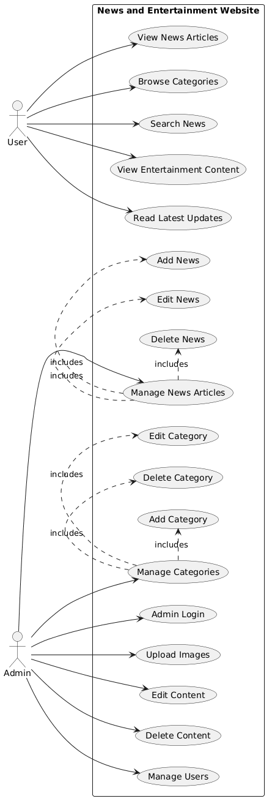

Figure no: 1 It shows use case diagram

4.7 ER Diagram

E.R. diagram

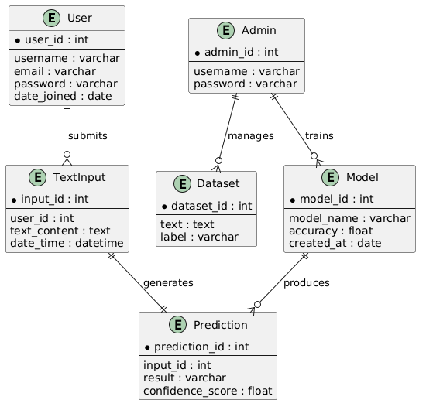

Figure no :2 It shows ER diagram

4.8Flow Chart
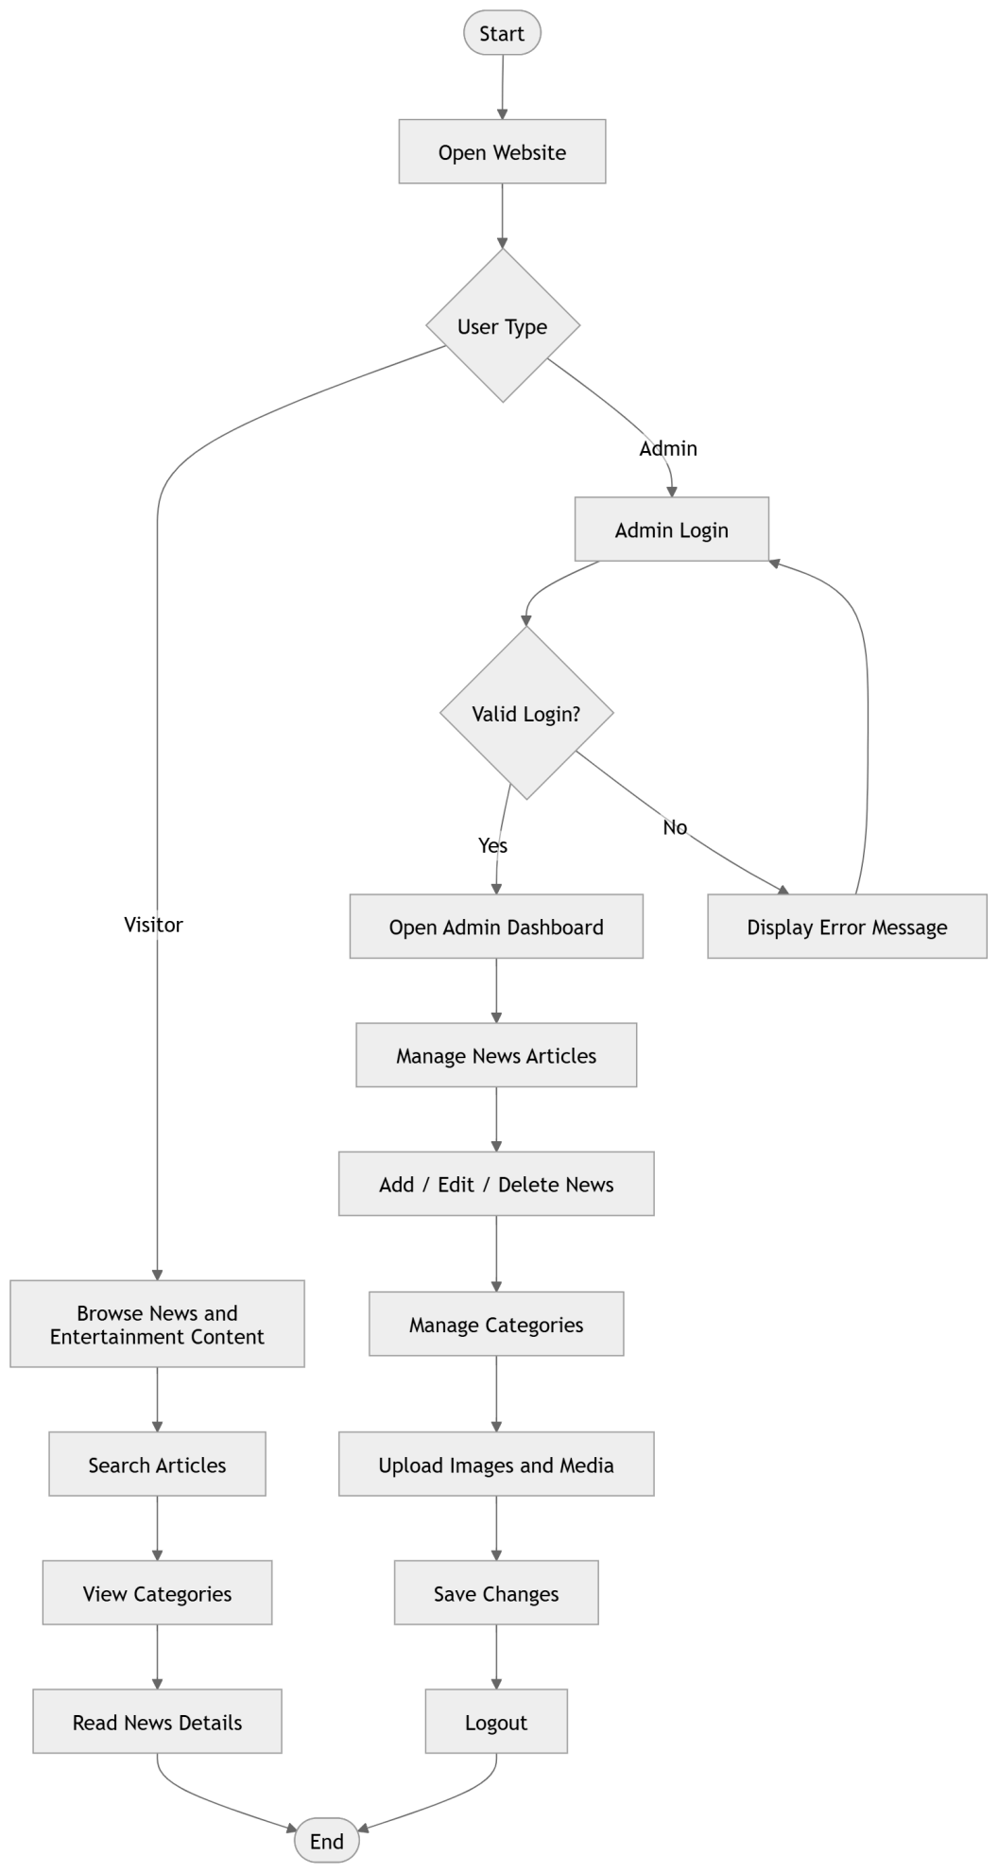

Figur

e no:3 It shows Flow Chart

4.9 Future Directions
- The system can be further improved by integrating real-time monitoring of social media platforms such as comments, posts, and chat messages to instantly detect harmful or abusive content.
- Mobile applications for both Android and iOS can be developed to increase accessibility and allow users to use the system on different devices.
- An AI-based chatbot can be added to guide users, explain prediction results, and provide assistance related to cyberbullying detection and prevention.
- Voice-based input features with multilingual support can also be implemented, enabling users to detect cyberbullying through speech in different languages.

4.10 Conclusion
The Cyberbullying Detection System is a web-based application developed using Django, HTML, CSS, JavaScript, and Machine Learning techniques. The system enables users to input text and automatically classifies it as bullying or non-bullying using NLP-based preprocessing and trained machine learning models. It provides a simple and user-friendly interface where users can log in, submit text, and receive instant predictions.
The system contributes to improving online safety by efficiently identifying harmful and abusive content. It plays a significant role in reducing cyberbullying and promoting responsible communication in digital environments.

4.12 Testable Requirements

System testing is an essential phase used to verify the functionality, accuracy, and performance of the Cyberbullying Detection System. It ensures that the system operates correctly according to the defined requirements and produces reliable results.

Unit Testing:
This level of testing focuses on individual components such as text preprocessing, model prediction, and user input handling. Each module is tested separately to ensure proper functionality.

Integration Testing:
This testing verifies the interaction between different system components, including the Django backend, machine learning model, and frontend interface. It ensures smooth data flow and correct communication between modules.

System Testing:
The complete system is tested as a whole to confirm that all functional and non-functional requirements are satisfied, including accuracy, performance, and usability of the application.

Acceptance Testing:
This testing is performed by end users to ensure that the system meets their expectations. Users validate whether the system correctly detects cyberbullying content and provides accurate and consistent results before deployment.

.

4.13 Test results

-

4.14 Interface

Chapter 5: Conclusion and Recommendations
This chapter presents the summary of objectives, conclusions, and recommendations for the Cyberbullying Detection System developed using Django and Machine Learning techniques.

5.1 Summary of the Objectives
This project focuses on the development of a Cyberbullying Detection System that provides both user and administrative functionalities. Users are able to register, log in, and input text messages for analysis to determine whether the content is classified as bullying or non-bullying. The system utilizes a trained Machine Learning model integrated into a Django-based web application to process and classify user input.
The system successfully achieved most of its defined objectives. It allows users to input text, receive instant predictions, and view classification results. Additionally, the system stores prediction history for future reference, improving usability and tracking. The administrative module supports dataset management and model training operations. Overall, the system contributes to improving online safety by helping users detect harmful content efficiently.
However, some challenges were encountered during development, including limited dataset availability and variations in model accuracy depending on text complexity. Furthermore, the system currently supports only English text and requires internet connectivity for web-based access.

5.2 Cocconclusions
The primary goal of this project was to design and implement an intelligent system for detecting cyberbullying content using Natural Language Processing and Machine Learning techniques. The system successfully identifies abusive or harmful text and classifies it as bullying or non-bullying through a user-friendly Django web interface

AltAlhough the system meets its core objectives, there is still room for improvement. Enhancing
model accuracy, supporting multiple languages, and enabling real-time detection are key areas for future enhancement. Overall, the system provides an effective and practical solution for promoting safer online communication and reducing cyberbullying.

5.3 Recommendations
To enhance the performance, security, and usability of the system, several improvements are recommended.
Session management should be implemented to automatically log out inactive users, improving system security and preventing unauthorized access.
The system should also be trained using larger and more diverse datasets to improve prediction accuracy. Advanced Machine Learning techniques such as BERT and deep learning models can be integrated for better classification results.
Additionally, user awareness and proper system usage guidelines should be provided to ensure effective interaction with the application. Future development should focus on multilingual support, real-time social media integration, and mobile application development to increase accessibility and efficiency.

References

General References
- Baum-Snow, N., & Ferreira, F. (2015). Causal inference in urban and regional economics. Elsevier.
- Bertino, E. (2016). Data security and privacy: Concepts, approaches, and research directions. Information Systems Journal.
- Feather, C., & Meme, C. K. (2019). Strengthening housing finance in emerging markets. Housing Studies.
Isaias, P., & Issa, T. (2015). High level models and methodologies for information systems. Springer.
Lee, C.-H., Wang, Y.-H., & Trappey, A. J. (2015). Ontology-based reasoning for intelligent systems.
- Goodfellow, I., Bengio, Y., & Courville, A. (2016). Deep Learning. MIT Press.
- Jurafsky, D., & Martin, J. H. (2023). Speech and Language Processing. Pearson.

Project-Specific References
- Afzal, S., et al. (2021). Cyberbullying detection using machine learning techniques. Journal of Emerging Technologies and Innovative Research.
- Gommans, H. P., et al. (2014). Text classification and content moderation systems. International Journal of Scientific and Research Publications.
- Ikuomola, A. J. (2020). Machine learning-based text classification systems. ResearchGate.
Kirmani, J. A., et al. (2017). Machine learning approaches for text analysis systems. International Journal of Computer Science.
- Miyasam, M. R., & Selamat, N. (2021). Cyber text classification and sentiment analysis systems. Applied Information Technology Journal.
- Rathore, K., et al. (2021). Machine learning-based content classification systems. International Research Journal of Engineering.
- Voumick, D., et al. (2021). AI-based web applications for text classification. Journal of Software Engineering.

